**Project 2   
Deploy a Static Website on AWS**

## Step 1: Create a bucket

1. Sign in to the AWS Management Console and open the Amazon S3 console at https://console.aws.amazon.com/s3/.

2. Choose the Region where you want to create the bucket.

3. Choose Create bucket.

4. Enter the Bucket name (for example, example.com).

5. To accept the default settings and create the bucket, choose Create.

## 

## Step 2: Enable static website hosting

After you create a bucket, you can enable static website hosting for your bucket. You can create a new bucket or use an existing bucket.

1. In the Buckets list, choose the name of the bucket that you want to enable static website hosting for.

2. Choose Properties.

3. Under Static website hosting, choose Edit.

4. Choose Use this bucket to host a website.

5. Under Static website hosting, choose Enable.

6. In Index document, enter the file name of the index document, typically index.html.

7. To provide your own custom error document for 4XX class errors, in Error document, enter the custom error document file name.

8. Choose Save changes.

9. Under Static website hosting, note the Endpoint.

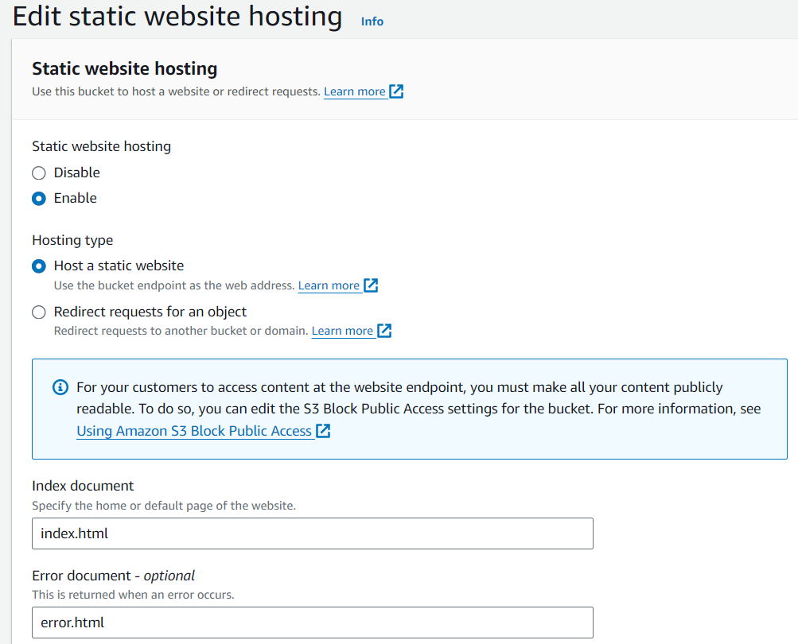

## Step 3: Add a bucket policy that makes your bucket content publicly available

After you edit S3 Block Public Access settings, you can add a bucket policy to grant public read access to your bucket. When you grant public read access, anyone on the internet can access your bucket.

1. Under Buckets, choose the name of your bucket.

2. Choose Permissions.

3. Under Bucket Policy, choose Edit.

4. To grant public read access for your website, copy the following bucket policy, and paste it in the Bucket policy editor.

5. Update the Resource to your bucket name.

6. Choose save changes

{

"Id":"Policy1",

"Version":"2012-10-17",

"Statement":[

{

"Sid":"Stmt1",

"Action":[

"s3:GetObject"

],

"Effect":"Allow",

"Resource":"replace-this-string-with-your-bucket-arn/*",

"Principal":"*"

}

]

}

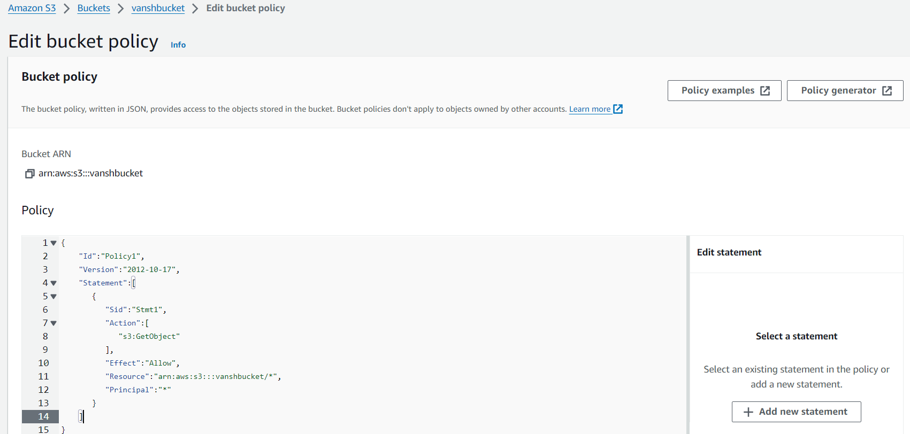

## Step 4: Configure an index document and error document

When you enable static website hosting for your bucket, you enter the name of the index document (for example, index.html). After you enable static website hosting for the bucket, you upload an HTML file with this index document name to your bucket.

1. Create an index.html file.

2. Create an error document, for example 404.html.

3. Save the index file locally.

4. Save the error document file locally.

5. Index document file name must also be index.html and not Index.html.

6. The error document name is case sensitive and must exactly match the name that you enter

7. To upload the index document to your bucket

8. To upload the error document to your bucket

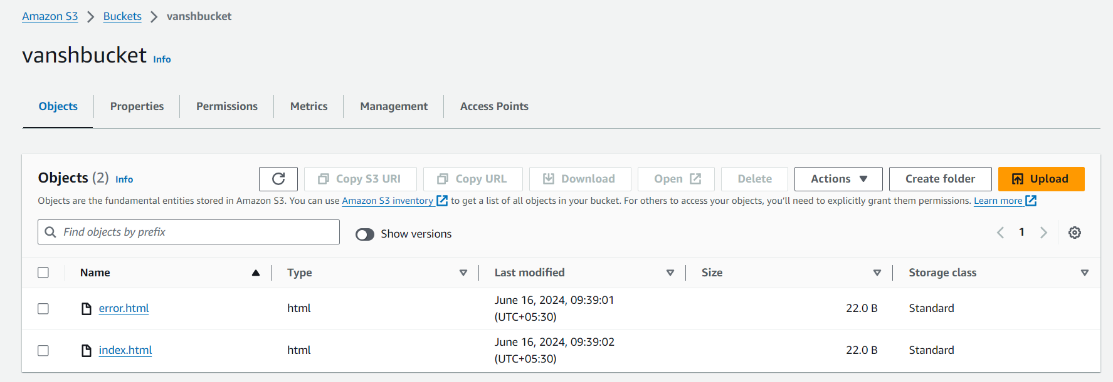

## Step 5: Test your website endpoint

After you configure static website hosting for your bucket, you can test your website endpoint.

1. Under Buckets, choose the name of your bucket.

2. Choose Properties.

3. At the bottom of the page, under Static website hosting, choose your Bucket website endpoint.

Your index document opens in a separate browser window.

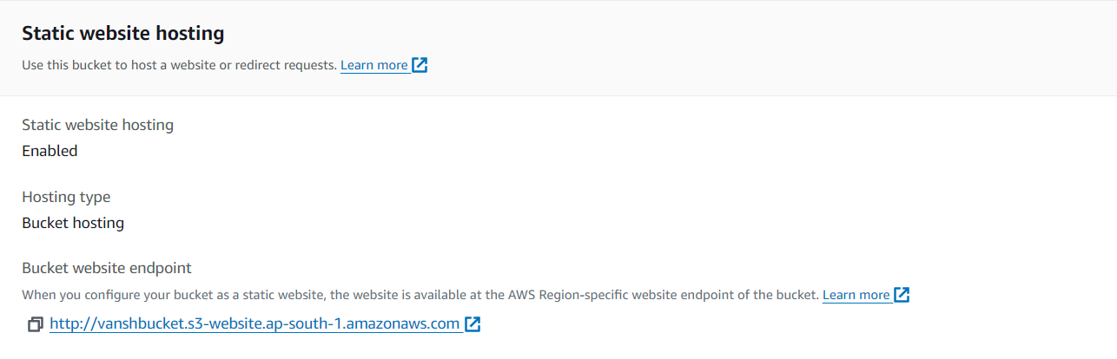

## Step 6: Clean up

If you created your static website only as a learning exercise, delete the AWS resources that you allocated so that you no longer accrue charges. After you delete your AWS resources, your website is no longer available. For more information, see [Deleting a bucket](https://docs.aws.amazon.com/AmazonS3/latest/userguide/delete-bucket.html).